Exercise 5.43

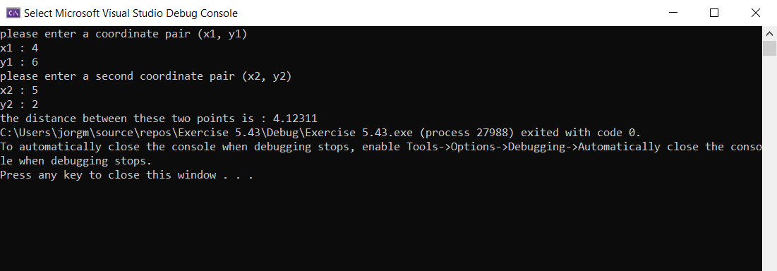

#include <iostream>

#include <cmath>

using namespace std;

double distance(double x1, double y1, double x2, double y2) // function to calulae the distance between two coordinate pairs

{

double dist = sqrt(pow(x2 - x1, 2) + pow(y2 - y1, 2)); // make variable dist equal to the distance formula using sqrt function and pow function

return dist; //return the double dist

}

int main() // main function

{

double x1, y1, x2, y2; //declare variables for each of the coordinates

cout << "please enter a coordinate pair (x1, y1)" << endl; //prompt user to enter a coordinate pair

cout << "x1 : "; // prompt user to enter x1

cin >> x1; //take the input

cout << "y1 : "; //prompt user to enter y1

cin >> y1; //take the input

cout << "please enter a second coordinate pair (x2, y2)" << endl; // prompt user to enter second coordinate pair

cout << "x2 : "; // promt usr to enter x2

cin >> x2; // take the input

cout << "y2 : "; //prompt user to enter y2

cin >> y2; // take the input

cout << "the distance between these two points is : "<< distance(x1, y1, x2, y2); // print the distance between both coordinate pairs by calling the function distance

}